ELEC-2110

Electric Circuit Analysis

FROM: Jacob Howard

TO: Markus Kreitzer

DATE: February 26, 2020

LAB SECTION: 002

Electrical Measurements:

First‐Order Transient Circuits

# **Introduction**

Summery……….

# **Exercise 4**

Explain exercise 4……..

Exercise 1-3 was to prepare for lab.

Insert equations for 4

# **Exercise 5**

Explain exercise 5……

Insert equations

# **Exercise 6**

Explain exercise 6…..

dT represents tou on the graph below, C1 curser is on zero and C2 curser is V(tou).

|  |  |
| --- | --- |
| **Name** | **Value** |
| **Vs** | 15.631 V |
| **R1** | 329.36 Ω |
| **R2** | 321.89 Ω |
| **C** | 7.8 uF |

*Chart 1*

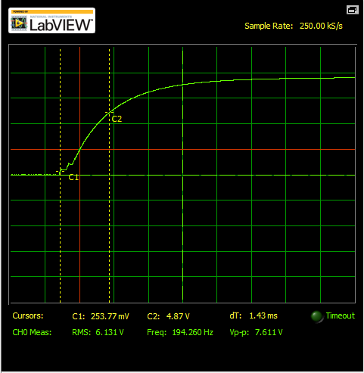

*Graph 1*

|  |
| --- |
| c = 7.8e-6;  vs = 15.631;  r1 = 329.36;  r2 = 321.89;    %CL -> OP  vc = vs*r2/(r1+r2)  vc = 7.62  tau1 = c*r2*1000  Vtau1 = 0+(vc-0)*exp(-1)    %OP -> CL  rth = 1/(1/r1 + 1/r2)  tau2 = rth*c*1000  Vtau2 = vc +(0-vc)*exp(-1) |

*Matlab code*

# **Exercise 7**

Explain exercise 7…

Calculate using matlab code

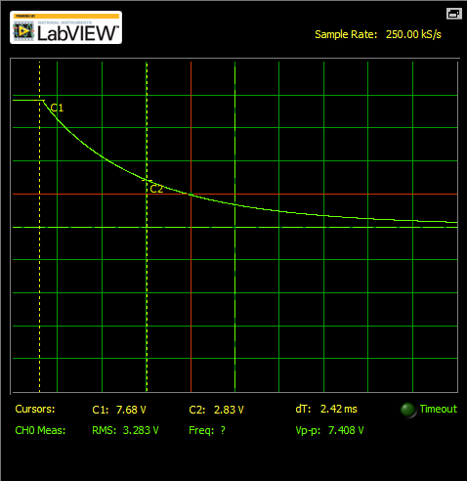

*Graph 2*

|  |
| --- |
| c = 7.8e-6;  vs = 15.631;  r1 = 329.36;  r2 = 321.89;    %CL -> OP (on to off)  vc = vs*r2/(r1+r2)  vc = 7.68  tau1 = c*r2*1000  Vtau1 = 0+(vc-0)*exp(-1)    %OP -> CL (off to on)  rth = 1/(1/r1 + 1/r2)  tau2 = rth*c*1000  Vtau2 = vc +(0-vc)*exp(-1) |

*Matlab Code 2*

# **Exercise 8**

Explain exercise 8….

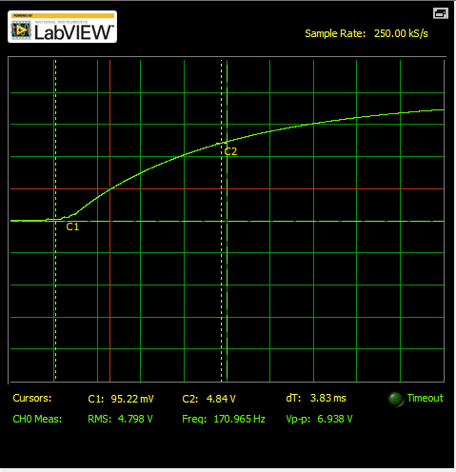

Graph 3

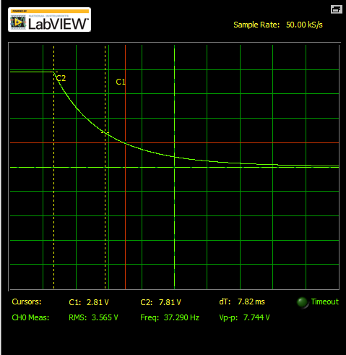

Graph 4

|  |
| --- |
| c = 7.8e-6;  vs = 15.631;  r1 = 985.3;  r2 = 993.1;    %CL -> OP (on to off)  vc = vs*r2/(r1+r2)  vc = 7.68  tau1 = c*r2*1000  Vtau1 = 0+(vc-0)*exp(-1)    %OP -> CL (off to on)  rth = 1/(1/r1 + 1/r2)  tau2 = rth*c*1000  Vtau2 = vc +(0-vc)*exp(-1) |

Matlab code 3

# **Conclusion**

Explain the lab conclusion…….

Bibliography

[1] Some bibliography of the lab….